OnlineNIC Reseller's Template 4.0 System

Introduction

The users of Template 4.0 include Super-Administrator, Administrators, Members.

1. Super-Administrator

Super-Administrator is the highest master of Template, with access to implement all the operations in template. Super-Administrator has access to add or delete Administrators, set system settings, set the access limitation for each Administrator and manage all members and domains.
The fixed login ID of Super-administrator is 100. Super Administrator has privilege to do following tasks.

Super-admin Area

Administrator List
System Setting
Email settings
Configure gateway

Product Management
Domain Settings Domain Upgrade
Manage Domain
Manage DNS Register Domain
Domain Sync Domain Lock Domain Autorenewal
Member Management
Member List Account Management
Funds Management
Query Transaction
Other operation
Whois Search

2. Administrators

Template 4.0 enables Super-Administrator to create some administrators between Members and himself to share his work. For example, Super-Administrator may create finance Administrator, who is exclusively in charge of member's funds management, and also create pricing Administrator, who is responsible for making domain prices, etc. The establishment of administrators will help Super-Administrator better manage the whole system.

The Super administrator can control the access of administrators on the following tasks. The tasks assigned to administrators depend on their departments.

Domain Renewal
Domain Lock
Configure Gateway
Dns Manage
Email settings
Domain Sync
Whois Search
Query Transaction
Funds Management
Member List
Register Domain
Manage Domain
Domain Upgrade
Domain Setting

3.Members

The end users of the system. The members can register domain, manage domains. They can do the following tasks.

Business Tools
Whois Search
Register Domain
Manage Domain

Member Tools
Modify Account Info
Forgot Password
Transaction History

Product Management
Manage DNS
Domain Lock
Domain AutoRenewal

Fund Management
Manage Funds

New Features Added in Super Administrator's and administrator's tasks :
1. Email Settings
This feature helps to set options of notification email for domain registration, domain renewal and password retrieval. The mail transfer agent can be sendmail or SMTP.
1. We can customize email structure and save.
2. There is an option to send test mail also.
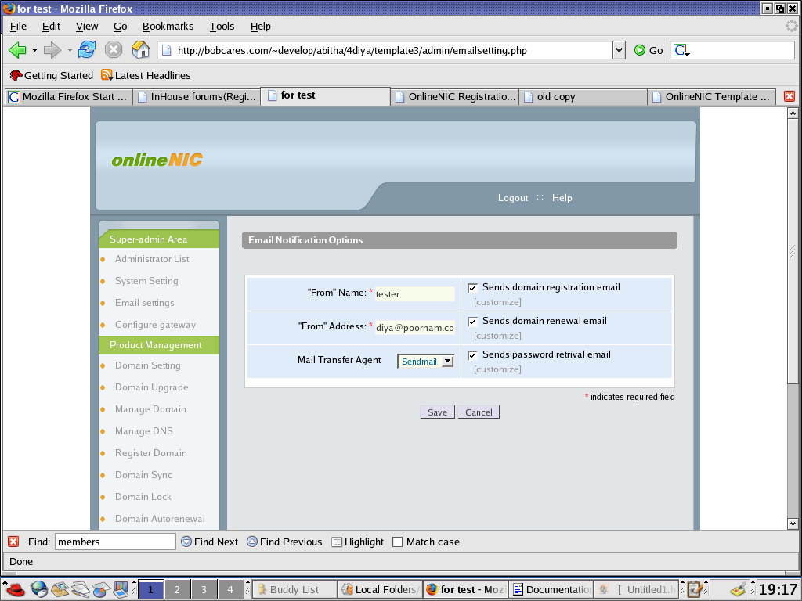Screen Shot : Email Setting

In this we can customize email setting , select mail sender agent and save the setting.

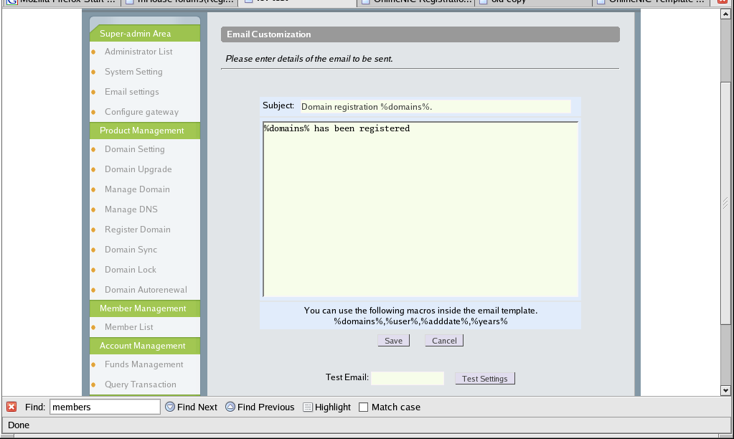The customize page of domain registration notification look like the following screenshot.
There is an option to send test mails also.
2. Configure Gateway
This feature enables to set paypal and worldpay details settings. We can change l email, enable test mode or not for paypal. We can change email, callback password for worldpay.
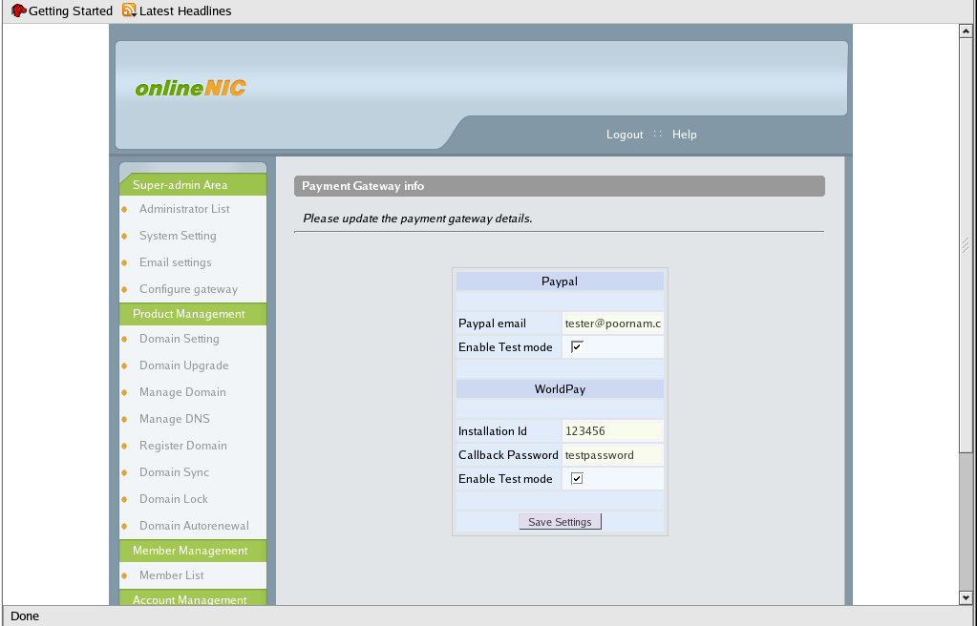Screenshot : Configure Gateway

3. Domain Sync
This feature helps you to search for domain sync option for a domain of member. You have to enter domain and username details in the page and query for domain sync.
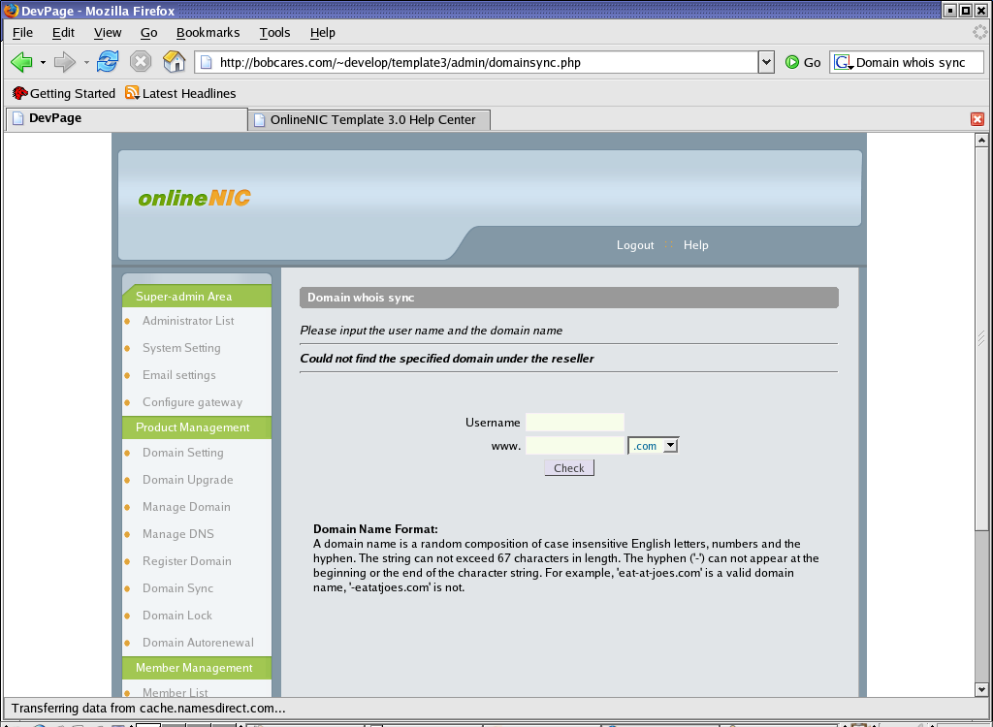Screenshot : Domain Sync

4. Domain Lock
Domain locking prevents unwanted registrar transfers and DNS changes to the domain names. You can lock or unlock the domains you want. There will be a list of all domains showing they are locked or not. You can select one or more domains and request for lock or unlock. There is a query option also . You can search for domains you want and request for lock or unlock.
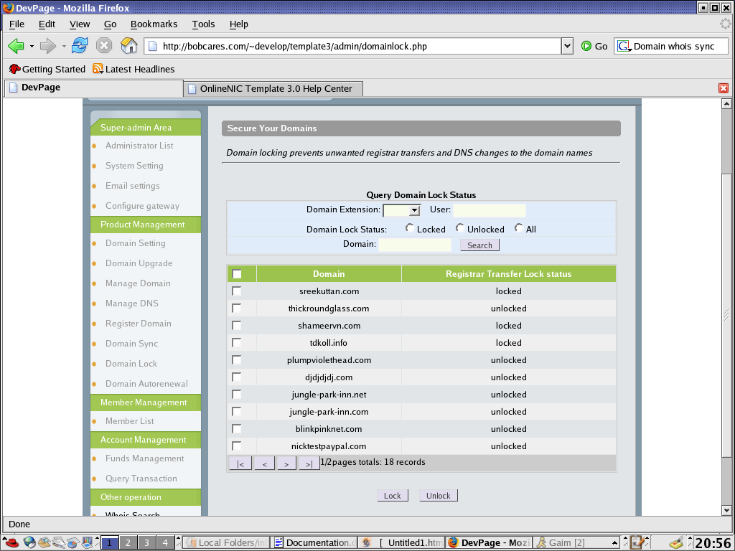Screenshot : Domain Lock

5. Domain Autorenewal This feature allows to change domain autorenewal facility for one or more domains. We can either select domains from the list shown on the main page or query for the domains you want. All details are given in the page itself. You have to agree Domain AutoRenewal Agreement.
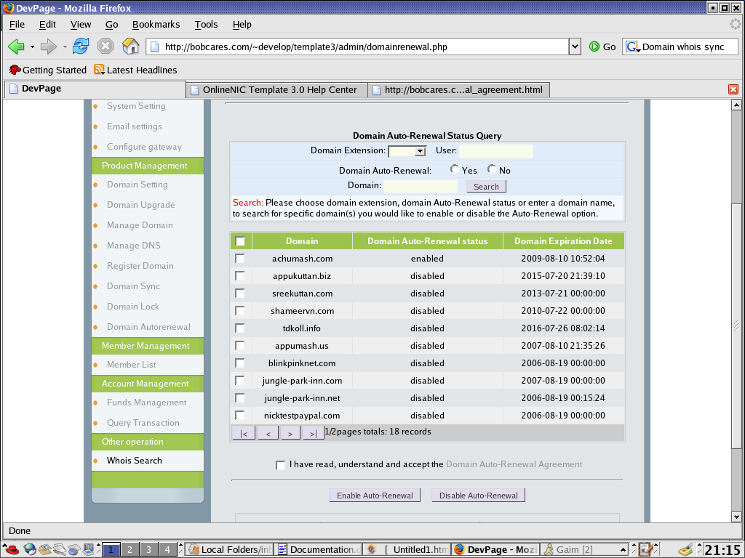Screenshot : Domain AutoRenewal

6. Manage DNS This feature allows to add new name servers or edit the existing nameservers. You have to enter name server and corresponding IP for adding new DNS. We can select any DNS and edit.
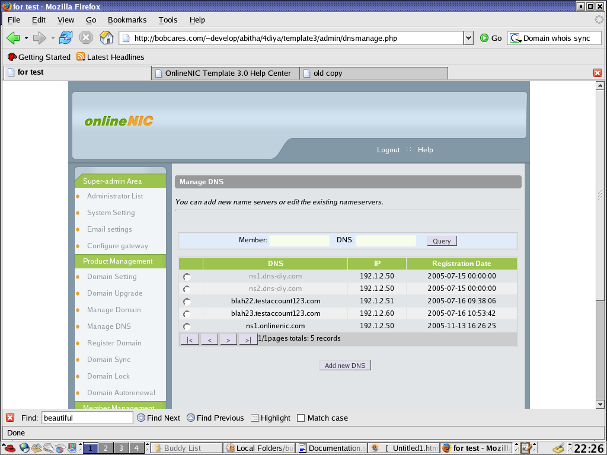Screenshot : Manage DNS

Modified Features

1. Super Admin's Area

Administrator List
New tasks such as Domain Renewal, Domain Lock, Configure Gateway, Dns Manage, Email settings and Domain Sync are added in Administrator ---->Access Setting.

System Settings New entry for changing theme of the system . Entry for website skin is removed.

2. Product Management

Register Domain This feature is modified in such a way that we can enter 10 desirable domains with selected extensions for checking availability. （Note：Your HTTP time-out parameter should be set to 300, or you will get an error page.）

3. Member Management

Add new member feature is added in this page. There is no such option for this page in old version.

New Features Added in Member Area
New section product management is added for members. Product management contains following features.
1. Manage DNS This feature allows to add new name servers or edit the existing nameservers. You have to enter name server and corresponding IP for adding new DNS. We can select any DNS and edit.
Screenshot : Manage DNS

2. Domain Lock
Domain locking prevents unwanted registrar transfers and DNS changes to the domain names. You can lock or unlock the domains you want. There will be a list of all domains showing they are locked or not. You can select one or more domains and request for lock or unlock. There is a query option also . You can search for domains you want and request for lock or unlock.
Screenshot : Domain Lock

3. Domain Autorenewal This feature allows to change domain autorenewal facility for one or more domains. We can either select domains from the list shown on the main page or query for the domains you want. All details are given in the page itself. You have to agree Domain AutoRenewal Agreement.
Screenshot : Domain AutoRenewal

